

**Terminal 1 P2 Main Hall PLC watchdog failure Incident Summary dated 03/08/2023**

**Introduction**

Dear All

Please read and digest the Terminal 1 P2 Main Hall PLC watchdog failure Incident Summary 03/08/2023 and cascade to those who require it.

**High Level Summary**

This incident was the result of multiple main hall PLC watchdog failures affecting routes from transport lines onto main hall east and west sorters as well as exit routes. This resulted in the BCCR having no visuals of this area and no health status. Due to this loss of status a controlled stop of check in and transfer inputs was performed to contain the issue and avoid potential congestion. Low level CST then performed a PLC reboot of area and status was returned, main hall sorter routes required local restarts which were performed from the engineering team. Once routes were started and fault free, check in and transfer inputs were restarted.

After the initial incident two South Side E-Stops knocked out large areas of the T1 Main Hall system, it then became clear that the BCCR main hall PLC start commands from SCADA/VISCA were not starting conveyors in the system. This Issue was linked to the earlier MHPLC watchdog fail. Local restarts were again required by the engineering team which impacted the system recovery time. As the BCCR still had status on these areas on SCADA/VISCA no further controlled stops of inputs were required. Due to the main hall PLC issues bags were unable to discharge automatically from the T1 Bag store. This required a manual process from the engineer team to discharge product.

During this period Level 25 experienced congestion from the back log of direct product and this area had an increase in BAU faults affecting bag flow. Bags were penned at check in with approx. 250 bags and these were then reintroduced on zones A/B which had better baggage flow.

Once local routes were restarted, bag store began to discharge automatically and level 25 congestion cleared, the incident was then reduced from a P2 to a P3 while ongoing CST investigation was being carried out on main hall PLC.

**Operational Summary**

18:57 – Multiple Main hall PLC watchdog failure alarms populated and affected all routes into and out of Main hall East and West sorters. Routes were Black on VISCA and BCCR could not see health status of conveyors. This was escalated to T1 duty engineer who escalated issue immediately to Low level CST.

19:00 – Check in and transfer inputs were stopped to contain issue and prevent system congestion surrounding the main hall sorters. Due to the time of night this was raised as a P2 immediately. During this time it was established CST were to perform a local reboot of the main hall PLC. If this failed It was agreed with the terminal BSM that purge points would be stood up.

19:15 – PLC reboots were performed and status returned to affected areas – BCCR began to attempt starts on areas which were unsuccesful meaning local starts by engineers were needed. This meant the start of inputs were delayed, once routes were healthy and operational check in and transfers would be started.

19:25 – Check in and transfers began to be restarted – due to an earlier fault affecting HBS02 Route affecting check in zones C/D wave 2 and 3 were a single point of failure. This fault was advertised as a P3 @18:46. After the restart due to this issue aswell as the backlog zones C/D experienced a lot of intermittent dieback and BAU faults.

19:39 – South side E-Stop acivated on SDC158 affected all areas onto main hall east and west in the south. Flows were diverted north where possible by BCCR to maintain baggage flow.

19:42 – Press line was reset and BCCR attempted to restart routes onto main hall sorters which was unsuccesful. At this point it became clear that the PLC start commands from VISCA/SCADA were not affecting the live system. This was escalated to CST to investigate further – issue linked to earlier PLC Watchdog failure. Engineers were again tasked to start routes locally. Which was a succesful work around however time consuming. This impacted the system recovery.

19:45 – Level 25 began to experience congestion due to backlog from earlier check in stoppage resulting in a high number of faults. This was raised as a P3 and flows were diverted were possible.

20:00 – At this point it became apparent no bags were discharging from T1 bagstore. Bags could not see an exit route available. This again was linked to the earlier Main hall PLC issue. This was raised as a P3 and a manual process was implamented where engineers discharged bags in system. Approx 150 bags were affected with the nearest STD being 21:55. Contingency worked well and was being monitored throughout.

20:06 – Another South side E-Stop was activated of SDC 158 affecting areas onto main hall east and west sorters. This was immediately reset however unfortunately negated engineers local restarts carried out before. Meaning they had to begin again on affected routes. This elongated the recovery time further.

20:18 – Bags began to discharge automatically from T1 bagstore and manual process stood down. BCCR also noted being able to restart some routes from the main hall PLC command which was not working before. This helped speed up the recovery and return more routes to operation.

20:24 – All routes surrounding main hall East and West were now running and operatonal. This meant a more balanced system and began to reduce the system congestion.

20:50 – Level 25 Main hall and bagstore now running, incident was reduced from a P2 to a P3 for the rest of the operation. CST still investigating root cause, advising a possible CPU replacement required.

**Impact**

Initial analysis shows approx 42 INSYS but the total number of bags impacted by this incident will be verified by the VAO team.

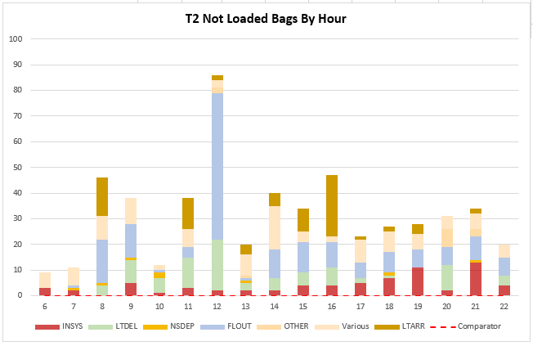

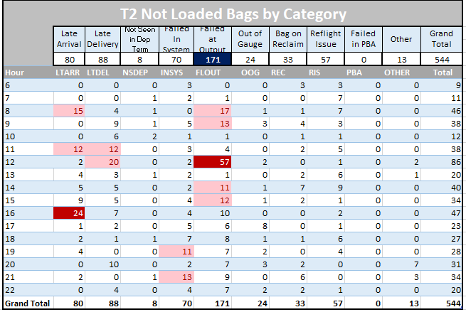

**Contingencies**

Controlled stop to check-in and transfer inputs. Bags being penned – CSOP C.

**Current Status**

System Green

**Root cause**

Awaiting final CST report and findings

**Technical update**



**Communications**

Communications were carried out regularly and were effective throughout with regular updates to all stakeholders verbally and via VIC and were reflective of the situation at each stage.

**Next steps**

|  |  |  |  |
| --- | --- | --- | --- |
| Action | Owner | Timescale | Status |
| VAO team to verify missed bags | VAO Team |  | Open |
| Root cause | LLCST |  | Open |

Regards

BCCR Team